SESSION 8 — Gearhaven
Beat 6 — The Grand Custodian (BOSS • Fight 4)

The Crossing
You leave the saved green of the plaza behind and head into the city, toward the giant. Gearhaven has emptied — the streets are abandoned mid-panic. A dropped basket of apples. A child’s wooden toy. A steam-tram stopped dead on its track, doors still open. The cheerful brass city you walked into yesterday has gone silent and afraid.
And ahead, rising over the rooftops, growing bigger with every street you cross, is the Grand Custodian — the gentle giant the whole city loves, the one the children wave to. The one whose slow heartbeat is the heartbeat of Gearhaven. It does not look gentle now.
And as you draw closer, Ursa — something strange happens. Your dragonmark, the Mark of Handling, the one that prickles when a frightened animal is near… it’s waking up. Reaching toward the giant. Which makes no sense. It’s a machine. Brass and gears. Your Mark has never once stirred for a machine. But it’s stirring now. Like there’s something alive in there. Something hurting.
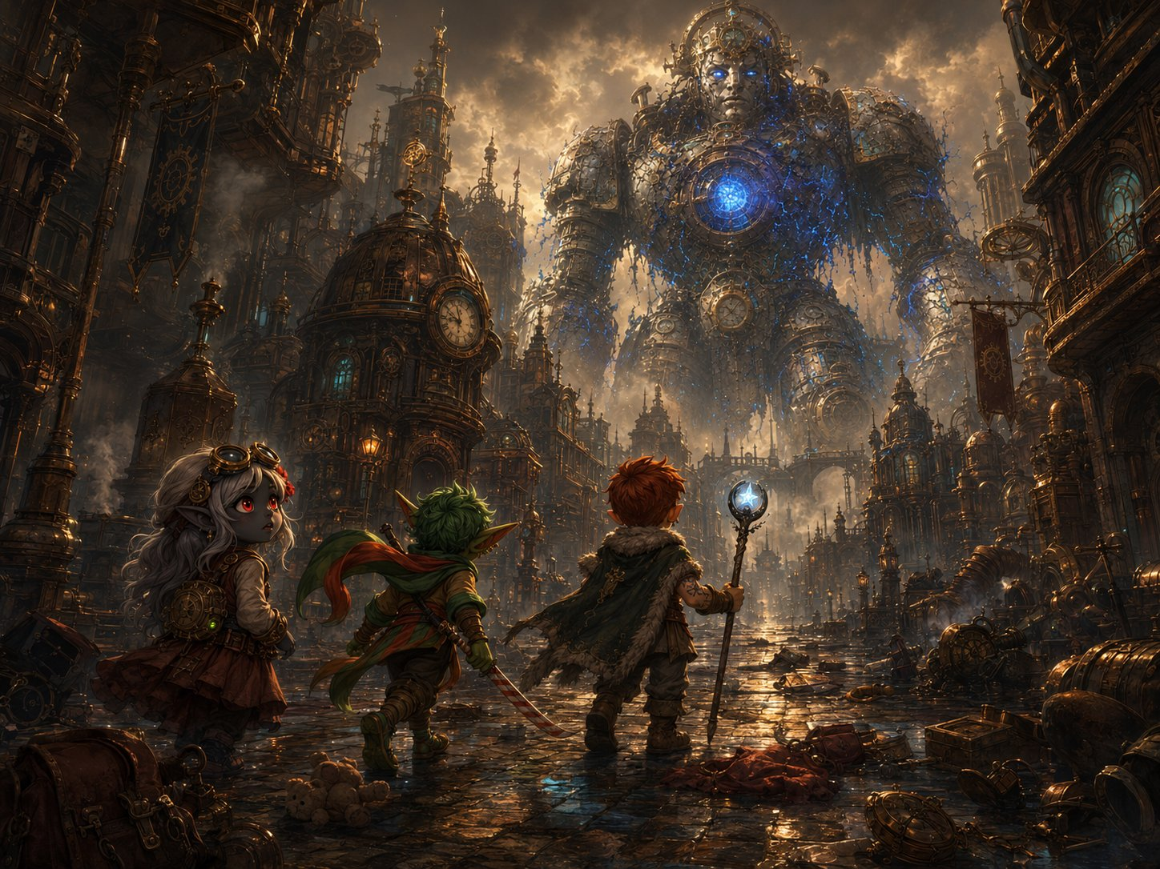
The Crossing — the heroes cross an emptied city toward the corrupted giant looming over the rooftops.
▶ Ursa’s Mark, planted (1 of 3). Don’t explain it. Ursa feels the wrongness of his own gift reaching for a construct — it draws him in and unsettles him. Why does my Mark think this machine is a scared animal? This thread pays off in the gentle death and seeds a mystery for the time skip.
Ursa: “My Mark — it’s pulling toward the giant. Like it’s a living thing in pain. But that’s impossible. It’s a machine. …Isn’t it?”
Lilly: “That’s the Custodian. It’s the biggest, kindest machine in the whole city. Whatever’s wrong with it is the same thing that’s wrong with everything — just… enormous.”
Stabby: “It’s the size of a CASTLE. …Okay. Okay, we’ve done big before. We have NOT done castle before.”

Up Close: The Rampage
You round the last building — and there it is, towering over you, close enough to feel the wind of it move. And it’s destroying the city.
Every slow, grinding step brings a giant brass foot down through a rooftop. It swings an arm and a clocktower folds and collapses in a roar of dust and gears. The corruption — that sick planar blue — crawls all over its body like glowing veins, pulsing from a great open core in its chest. Its kind, broad face is twisted in something awful, fighting itself.
Then, for just a moment, the giant’s eyes find you. And the blue flickers. And the real Custodian surfaces — terrified — and a voice, deep and slow and gentle, pushes straight into your minds the way Ghostbloom’s does:
“…run… please… I cannot… hold it… I do not want… to hurt… RUN—”
The blue floods back. The kind face vanishes. And the giant raises a vast brass fist toward you.
▶ Ursa’s Mark (2 of 3). Ursa feels this far more than the others — his Mark translates the giant’s emotions directly: not rage, but terror, grief, and shame at being forced to smash the city it was built to protect. The reframe that changes the whole fight: this isn’t a monster — it’s a kind soul trapped inside a body used as a weapon, and it’s begging. Let Ursa say it.
▶ Stabby’s idol (1 of 2 — strongest reaction yet). At the same moment, the idol does its most intense thing of the campaign: scorching one second, frozen the next, thrashing in his pocket like it’s responding to the giant’s corruption. When Stabby clutches it, the blue corruption nearest him flinches — recoils for a heartbeat, like it’s afraid of the little idol. Don’t explain it. Plant it deep.
Ursa (the reframe — give him this): “It’s not a monster! I can feel it — it’s SCARED, it’s sad, it doesn’t WANT to do this. There’s someone good trapped inside, and they’re screaming. We’re not here to kill it. We’re here to save it.”
Stabby (unsettled by the idol): “My idol just about jumped out of my pocket! And — did you SEE that? The blue stuff, it pulled back from me. Like it’s scared of… of this thing I carry. Why’s it scared of ME?”
Lilly: “Save it. Right. Save the city-sized rampaging machine. …We’re going to need a really good plan.”

The Huddle — Talk It Out
The giant takes another thundering step — another building comes down. You don’t have long. You duck behind a toppled tram to think, fast.
Here’s the problem, all of you, look at it together: it’s too big and too armored to just whack. The weak spot is obvious — that glowing core in its chest, where all the bad blue is pouring from. But it’s way up high, far out of reach. And every second you waste, it stomps another piece of the city flat. So how do you bring a giant down to size?
▶ Run this as a real (scripted) conversation. Go around the table. Each kid has a line that puts their piece of the puzzle on the board — a shy player can just read theirs. The plan comes together out of their own mouths. If anyone freezes, use the nudge-prompts below. The goal is for THEM to arrive at the plan, not for you to hand it to them.
Lilly: “My cannon — the force-blast mode — shoots way farther than my flamethrower. I can hit that core from all the way back here… if someone keeps the giant off me.”
Stabby: “My SASH! Elaria’s gift — I can FLY now, a whole minute! I’ll go straight up and smack that core in its stupid glowing face. But somebody fly up with me so I’m not all alone up there!”
Ursa: “My fire won’t reach that high — too far. But my star-bolts will, and so will my comet-magic. And I can summon my spirit-beast with WINGS to fight beside you, Stabby. Ghostbloom — go up with him too!”
Ghostbloom (DM): “I can fly where your feet cannot, small ones. I will guard the one who flies.”
▶ The dot-connecting line — offer it to Lilly or Ursa.
Lilly (the plan!): “Wait — WAIT. Its LEGS. If we smash its legs, it can’t walk anymore — it stops wrecking the city — AND the whole giant comes crashing DOWN, and then the core’s right there where we can ALL reach it! Legs first! Take out the legs!”

The Two Choices
There are two ways to fight the giant. The party can pick one, or (best) combine them. Lay them out and let the table decide.
CHOICE 1 — Topple It (go for the legs). Everyone can reach the legs on the ground — no flying, no range needed. Two reasons it’s smart: (a) breaking the legs STOPS the rampage so it can’t crush more of the city, and (b) when both legs drop, the whole giant CRASHES and the high-up core comes down to where everyone can hit it. Safer, everyone contributes, but it takes a bit longer (180 HP of legs first). The likely “main” plan.
CHOICE 2 — The Air Game (go for the core directly). Skip the legs and attack the glowing core right now, up high. Stabby flies up on the Sash; Ghostbloom and Ursa’s winged spirit-beast fly up with him; Lilly snipes the core with her Force Ballista (120 ft) and Ursa adds Guiding Bolts / star-arrows from the ground (his Produce Flame is too short — only 30 ft). Faster, but the fliers are exposed up there and the giant keeps rampaging through the city the whole time.
▶ Best of all: BOTH. Most groups will topple it (Choice 1) to stop the rampage and bring the core down, then swarm the core (Choice 2 made easy) once it’s low. Reward whatever they come up with — there’s no wrong answer. Let their plan shape how Phase 1 plays.
▶ DM nudge-prompts (if the table stalls). “Stabby, what does that new sash of yours do again?” / “Lilly, how far does your cannon shoot compared to the flamethrower?” / “It just crushed another house — how do you stop it MOVING?” Feed these until the plan lands.
▶ The prep window (reward the huddle). Because they’re planning from cover before they strike, let everyone set up now, FOR FREE, before the fight starts: Ursa summons his Bestial Spirit (take the Air/fly option so it can reach the core) — on the board turn 1, no action spent — and can raise Starry Form; Lilly deploys her Eldritch Cannon (free via Pocket Dynamo) and sets it to Force Ballista mode, already aimed at the core; Stabby has his Sash ready; Ghostbloom positions to fly up; anyone drinking a potion or buffing does it now, free.
▶ THE REWARD. Because they planned and struck from concealment, the party has ADVANTAGE on their initiative rolls against the Custodian. (Simplest version: the whole party just goes first, before the giant takes a turn.) They open the fight with the plan already in motion — cannon aimed, spirit flying, Stabby airborne.

Fight 4 — Phase 1: Standing
The philosophy (keep this in mind all fight). These are the Chosen — they’re MEANT to win because they’re exceptionally strong. The Custodian is a spectacle they conquer, not a meat grinder. Its attacks look terrifying and exist to make the kids USE their cool defenses (Lilly’s Shield turning a hit into a miss, Stabby’s Deflect knocking the big bolt aside, Ursa’s summon tanking, Ghostbloom healing). Tune toward epic-and-demanding, never lethal. Nobody is expected to drop.
The situation. The giant towers over them, stomping through the city. Its core is ~40–50 ft up — too high for short-range stuff (Ursa’s Produce Flame at 30 ft can’t reach it), but Lilly’s Force Ballista (120 ft), Ursa’s Guiding Bolt (120 ft) and star-arrows (60 ft), and any flyer (Stabby on the Sash, Ghostbloom, the Air-spirit) can. The legs are ground-level — anyone can hit them. Win condition for the phase: drop both legs to 0 → it topples.
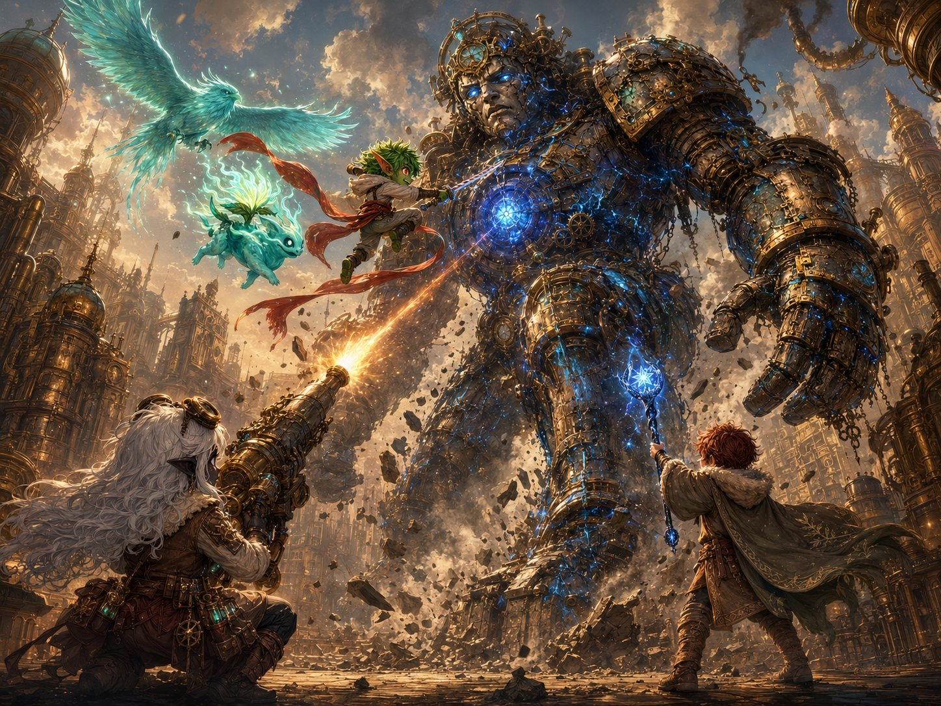
The plan in action — Stabby flies the core on his sash with Ghostbloom and the spirit-beast, while Lilly’s cannon and Ursa’s starlight strike from the ground.
▶ Running the fight (full stats on the Enemies page at the back). These are the Chosen — tune this as an epic spectacle they conquer, not a meat grinder. Phase 1: the giant rampages and attacks from above; the party breaks both legs to stop the rampage and bring the core down to everyone’s reach. Phase 2 (crashed): it unloads its scariest attacks. The Chain Lightning Burst is meant to be ANSWERED with Lilly’s Shield, Stabby’s Deflect, Absorb Elements, and Ghostbloom — not to drop a hero. Big scary numbers, chewed up by exceptional defenses.
▶ Why nobody drops (the safety net). Ghostbloom flies the air-game (heals + soaks); Ursa’s Bestial Spirit (30 HP) tanks 2–3 hits as a damage sponge; the party’s reactions + Healing Word absorb the scary numbers. If a hero dips low, Ghostbloom’s Guardian’s Light (1d8+3, ends fear) is the catch. And the seam: as the body nears death the attacks weaken and the blue light guts out — don’t let the final blow read as an execution; it’s the corruption breaking, not the giant being destroyed (see The Gentle Death).

The Crash — Into Phase 2
Read when both legs drop.
The second leg buckles. For a heartbeat the Grand Custodian hangs there, swaying — and then, with a groan like the whole world bending, it comes DOWN. It crashes to its knees, then its hands, a city-shaking BOOOOM that throws up a wall of dust and knocks loose every window for a block. The ground bounces. Your teeth rattle.
And now the great glowing core — once far overhead — hangs right in front of you, at the height of a house. Close enough to hit. Close enough to finish. But the giant isn’t done. Grounded, cornered, the corruption screaming through it, it hauls back and throws everything it has left at you.
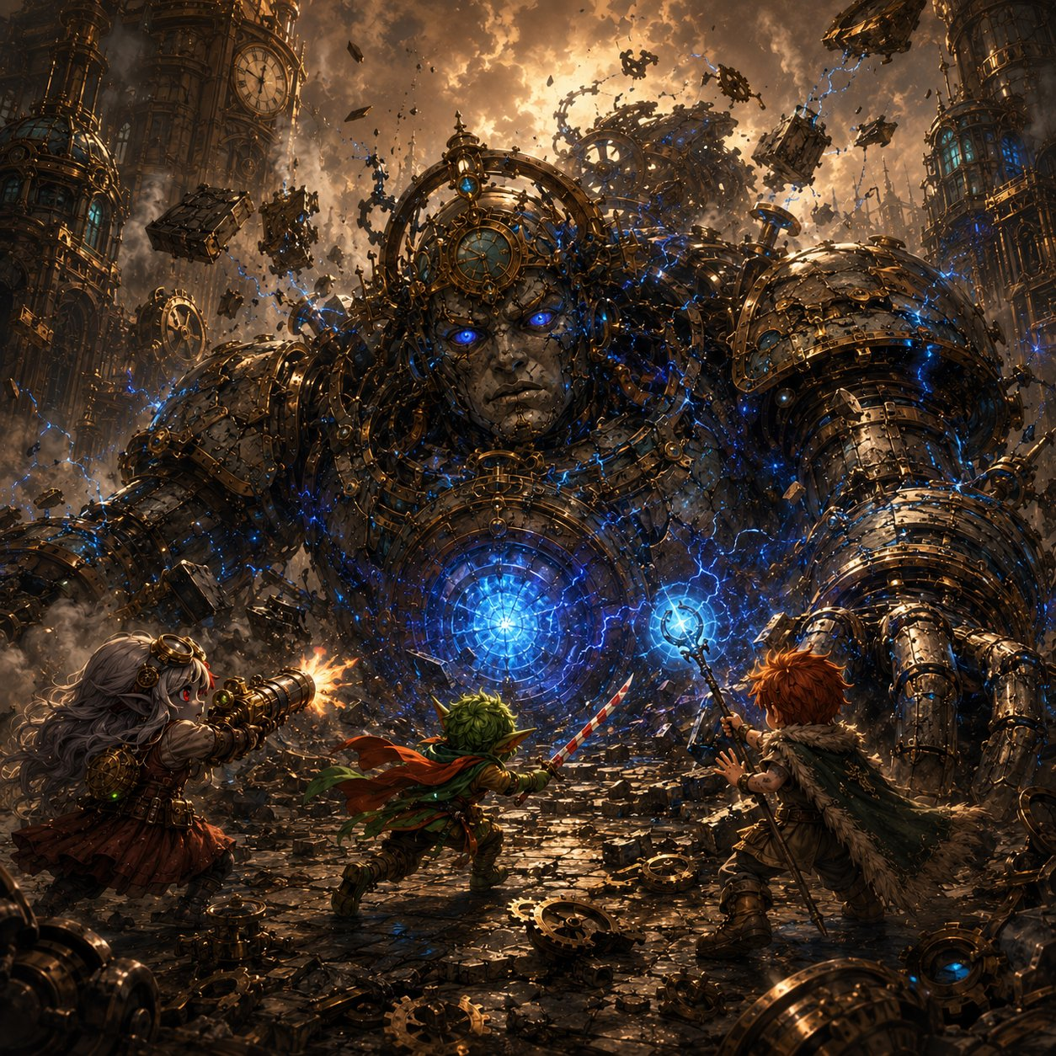
Phase 2 — brought low at last, the giant unloads a desperate barrage of clockwork and lightning, its core now within reach.

Stabby’s Monk Awakening
Drop this in at the scariest moment of Phase 2 — when the Chain Lightning Burst is about to land, or a friend’s in real danger. Stabby’s big moment.
The giant rears back, its core blazing white-hot, lightning crackling between its fingers — aimed right at the heart of your friends. There’s no time. And in Stabby’s pocket, the idol goes ice-cold and wrong, that creeping bad feeling clawing up his spine, screaming at him to panic.
And instead — Stabby breathes.
Master Kaelon’s voice, from years ago: “When the whole world is screaming, little storm — get still. Find the quiet in the middle of you. It is always there.”
And this time… he finds it. The chaos goes silent. The idol’s cold pull fades to nothing. For one perfect, impossible heartbeat, Stabby Sharpblade is not a goblin gremlin made of noise and mischief — he is a monk, calm as deep water, and the lightning is moving so… very… slowly. He steps into it. Catches it. Turns it aside.
▶ Stabby’s big spotlight — the idol/stillness collision. The idol (his creeping, corrupting unease) is the PROBLEM; the stillness Kaelon taught him is his ANSWER to it. Mechanically, let this be his Deflect Attack turning aside the Chain Lightning Burst (or Patient Defense, or a clutch save) — but narrate it as him finding the discipline for real for the first time. It SURPRISES him. He always shrugged the monk stuff off; now he’s felt what he could be — and there’s clearly more, if he ever went back and finished what Kaelon started. That plants his monastery door as an earned pull, not a footnote.
Stabby (after, a little stunned): “…Whoa. Did everyone see that? I — I went all quiet inside and the lightning just… slowed DOWN. Master Kaelon was RIGHT. There’s a whole me in here I haven’t even met yet.”
Ursa: “That was the calmest I’ve ever seen you. It was kind of beautiful, Stabby.”
Stabby: “Don’t get used to it. …But maybe. Maybe I gotta learn the rest of that someday.”

The Gentle Death
Read as the body drops — the final blow. The emotional peak of the session; let it breathe.
The last blow lands — and the great core cracks. The sick blue light doesn’t explode. It drains. It pours out of the cracks and the veins and the giant’s terrible eyes, hissing away into nothing, like floodwater finally let go. The corruption is leaving. And as it goes, the Grand Custodian stops fighting — its raised fist slows, sinks, lowers gently to the ground.
And the real Custodian comes back. Its huge kind face — the one the children wave to — softens. Its eyes, blue-white and clear now, blink slowly, and find the four of you standing before it. It looks at the city all around it, at the buildings it was forced to break, and an expression crosses its great face that, somehow, you all understand: sorrow. And then, looking at you: gratitude.
Ursa — your Mark is wide open now, a clear channel between you and the giant, and so when it speaks one last time, the deep gentle voice comes through you, soft as a hand on the shoulder:
“Thank you, little ones. You did not slay me. You set me free. …But hear me — I was only the first door it found. The tear in the sky is widening, and something far older and far hungrier is reaching through. The sleeping one feels it too, and stirs. Be ready. Be brave. …I am so very tired now. May I rest?”
And Ursa — somehow you know exactly what to do. The Mark of Handling isn’t only for calming frightened beasts. It’s for this, too. You reach out, the way you’d settle a tired old creature at the end of a long day, and you tell it, gently: yes. You can rest now.
The Grand Custodian closes its kind eyes. The great heartbeat under the city slows… softens… and goes quiet. And the giant settles into stillness — not broken, not destroyed. At peace. Finally, finally allowed to sleep. The whole city is silent. Somewhere, a single bird begins to sing.
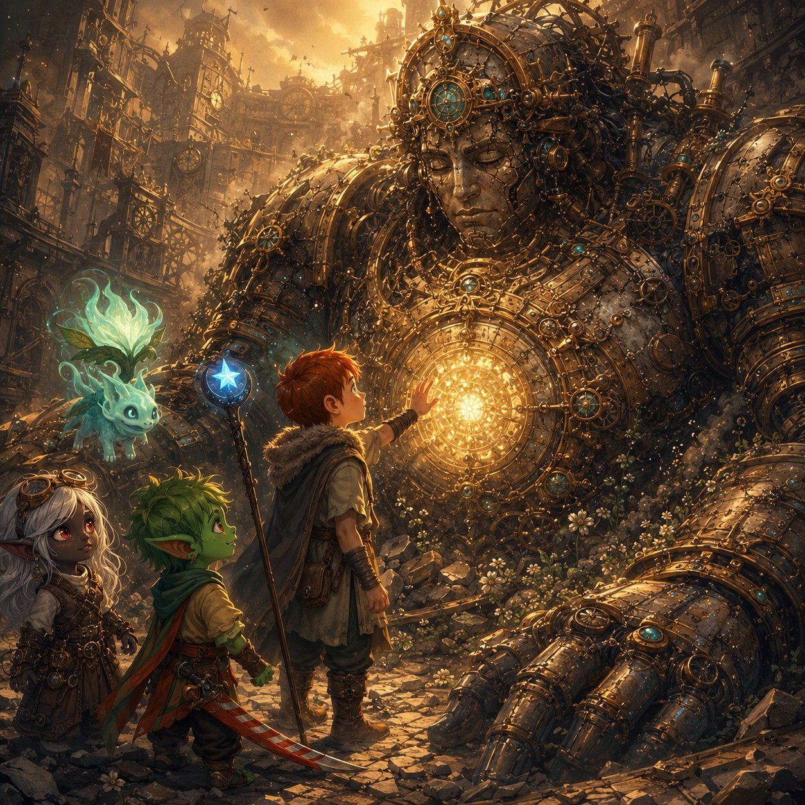
The gentle death — Ursa’s Mark gives the freed giant a peaceful rest as the corruption drains away.
▶ Ursa’s Mark (3 of 3) — the payoff. He’s the one the giant connects to, and he gives it a peaceful death — the Mark of Handling literally handing the giant its rest. Don’t rush it; if the kids are quiet, let them be. The warning (“only the first door,” “the sleeping one stirs”) seeds Maldrith and Elaria for the road ahead — file it for the Shadow Rift. Forward hook: Ursa now knows his Mark reaches corrupted things that shouldn’t be alive — a mystery and a calling he carries into the time skip.
Ursa (quiet): “Rest now. You did so well. You held on so long. We’ve got it from here.”
Lilly: “It said… the sleeping one. That’s Elaria, isn’t it? And something worse is coming through the cracks. …This was just the start.”
Stabby (gentle, for once): “Bye, big guy. You were the nicest giant I ever beat up.”

Hook — Into Beat 7
The danger is past. The city is saved. You’re battered, breathing hard, standing in the quiet beneath a sleeping giant — and for the first time in two days, nothing is trying to kill you.
And that’s when Lilly’s pack begins to glow. The Essence Sphere — her mother’s gift, the orb that holds Pikachu’s spark — is shining brighter than you’ve ever seen it. With all that planar corruption finally broken and gone, with motes of freed energy drifting in the air like fireflies… something inside the Sphere is stirring. Waking up. A small, warm, electric-yellow light, pulsing like a tiny heartbeat, getting stronger.
Lilly lifts it out with shaking hands. Inside the glass, for the first time ever, a little shape flickers — ears, a tail, two bright eyes blinking open. “…Pikachu?” Lilly breathes. “Are you— are you waking UP?”
End of Beat 6. Hard hook into Beat 7 — the Sphere upgrade + “Where Do You Go?” The Pikachu flicker bridges the threat of the session into the personal business of the send-off: the Sphere coming alive, Lilly’s remaining hooks landing, the in-character door-picks, and the hard cut to ONE YEAR LATER. End the beat here, on Pikachu’s eyes opening.
Seed check (final, before the send-off). Ursa’s Mark ✓ (stirred → read its grief → channeled the goodbye → mystery-hook for the skip). Stabby ✓✓✓ now fully fleshed out — flying-cloak core-striker (a real combat spotlight), idol’s strongest reaction (corruption flinches from him), AND the monk awakening (his “there’s a whole me I haven’t met” door, earned in the fight). Lilly’s Sphere/mote thread ✓ blazing into Beat 7. Every kid walks into the send-off with three doors felt.

ENEMIES — BOSS: The Grand Custodian
Gearhaven • Difficulty: Hard (but winnable) • Fight 4 • the two-phase boss
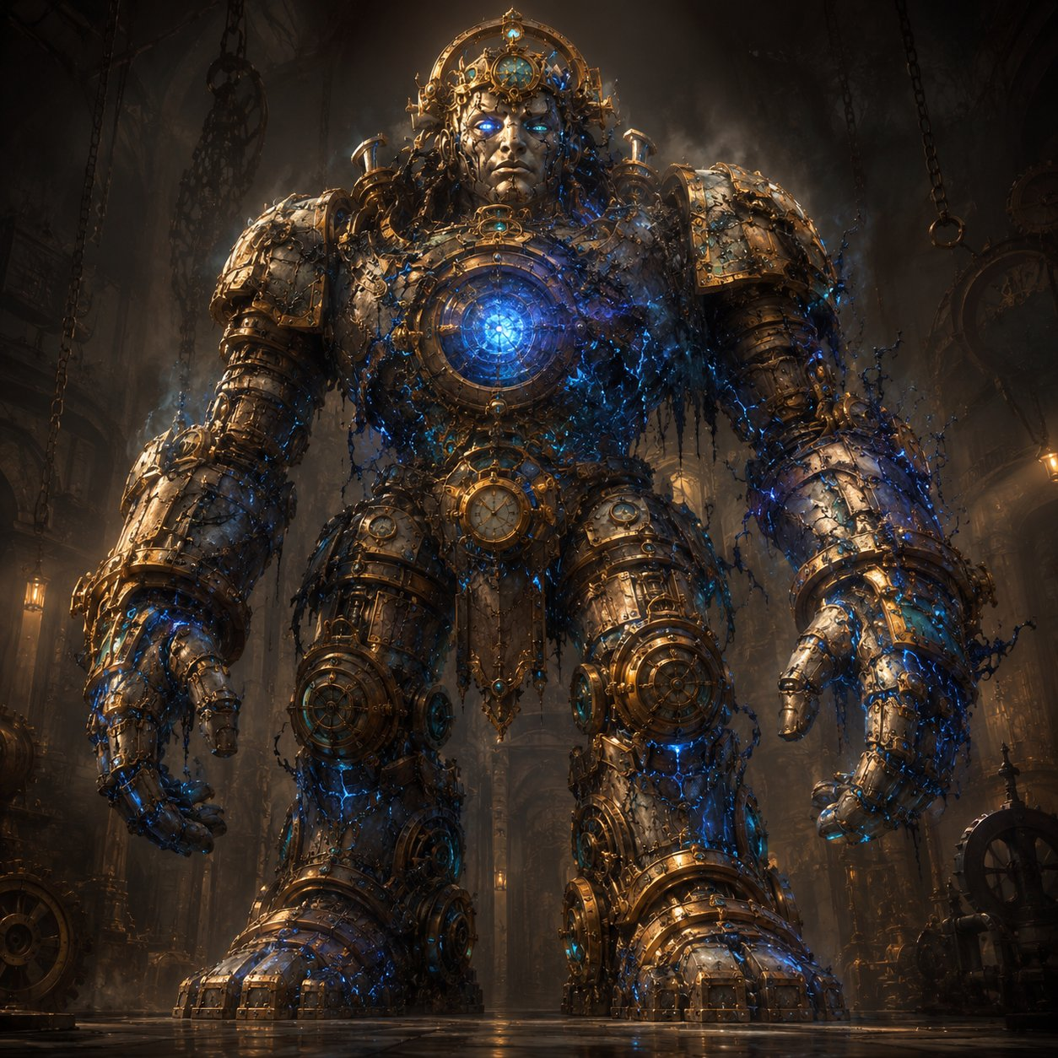
The Grand Custodian — the gentle giant that holds Gearhaven aloft, possessed by planar corruption.
Gargantuan construct (planar-possessed) • BOSS — Body: AC 17, HP 220. Legs (×2): AC 15, HP 90 each. Speed 30 ft.
STR 24 DEX 6 CON 22 INT 3 WIS 10 CHA 5 • Resist nonmagical B/P/S • Imm. charm/fear/exhaustion/poison/paralyze/petrify
How the fight works
The Core Is High. Standing, the core is ~40–50 ft up: only 60 ft+ ranged attacks and flyers reach it (Produce Flame at 30 ft can’t). The legs are ground-level — anyone can hit them.
Topple. Drop both legs (90 HP each) → it crashes to its knees (Phase 2), stops rampaging, and the core drops to ~15–20 ft where EVERYONE can reach it. It may slowly repair a leg (to 25 HP) to rise — re-topple to keep it down.
Phase 1 (standing)
Crushing Stomp. +8, reach 15 ft, 2d10+5 bludgeoning, DC 15 Dex or prone.
Sweeping Backhand (Rech 5–6). 15-ft cone, DC 15 Dex, 3d8 + shove 10 ft (half, no shove on save).
Corrupt Bolt. +8, 60 ft, 3d8 lightning — once/round at someone hanging back.
Phase 2 (crashed)
Clockwork Barrage (Rech 4–6). Three projectiles, +8 each, 2d8+3 bludgeoning.
Chain Lightning Burst (Rech 5–6). +8, 4d8 lightning, arcs to 2 more within 15 ft for 2d8 (DC 15 Dex half). The scary one.
Core Flare. Body below half HP: all within 20 ft, DC 15 Con or 2d6 force + blinded to end of next turn.
Crushing Stomp. Still swings fists in melee while kneeling.
Tactics: These are the Chosen — tune this as an epic spectacle they conquer, not a meat grinder. The giant rampages and attacks from above in Phase 1; the party breaks its legs to stop the rampage and bring the core into reach. Crashed in Phase 2, it unloads its scariest attacks — the Chain Lightning Burst is meant to be ANSWERED with Lilly’s Shield, Stabby’s Deflect, Absorb Elements, and Ghostbloom, not to drop a hero. Big scary numbers, chewed up by exceptional defenses. The body’s 220 HP gives the fight weight; the legs give fast, visible progress so it never drags. When the body falls, the corruption is driven out and the giant is FREED, not destroyed — play the gentle death, not an execution.
(Running Enemies page — Fight 1’s Rogue Servitor & Cargo Hauler on the Beat 2 sheet; Fight 2’s Voltcrawler & Broodmother on the Beat 4 sheet; Fight 3’s Iron Drudge & Corrupted Sproutling on the Beat 5 sheet. The Grand Custodian is the final boss of Session 8.)

